Table of Contents:

1. FEATURES
2. DESCRIPTION
3. TECHNICAL SPECIFICATION
3.1 SUMMARY SHEET
  - OPERATING AND COOLANT CONDITIONS
    - OPERATING CONDITIONS
    - COOLANT CONNECTIONS
    - COOLANT QUALITY
  - ELECTRICAL CONNECTION
    - POWER INPUT
    - MAIN CABLE AND LEADS
    - COLD HEAD CONTROLS
    - AUTO RESTART FUNCTION
4. INSTALATION
4.1 UNPACKING AND INSPECTION
  - MOUNTING
    - OPERATING ANGLE
    - FLEXLINES AND CONNECTIONS
    - COLD HEAD CONNECTION
5. OPERATION
5.1 SWITCHING ON
5.2 NORMAL OPERATION
5.3 SAFETY DEVICES
6. MAINTANANCE AND SERVICE
6.1 ABSORBER REMOVAL
6.2 HELIUM PRESSURE ADJUSTMENT
7. TROUBLE SHOOTING

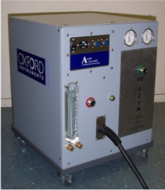

MAIN FEATURES

- Absorber can be replaced from the front of the unit, permitting convenient rack or cabinet installation.
- Both high and low side pressure gages.
- Electrical box is a field replaceable unit.
- High and low voltage units available for use at both 50 Hz and 60 Hz.
- Water flow meter provides user feedback to ensure adequate water supply.
- Compressor can be controlled remotely.

- Description

Compressed helium is used as a refrigerant when trying to achieve cryogenic temperatures (as low as 4 Kelvin). The high-pressure helium is delivered from the compressor to a cold head through the supply line (300-350 psi). The helium is expanded in the cold head to produce a temperature drop. The cold head uses a motor and a piston like “displacer” to move the expanded helium though regeneration materials to increase the thermodynamic efficiency of the cycle. After expansion, the helium returns to the compressor through the return line (50-100 psi). Theses magnets operate at cryogenic temperatures and the chilled radiation shield helps maintain these temperatures.
The compressor itself consists of five main components: The compressor capsule, the heat exchanger, the mist separator, absorber, and volume tank.
Compressing helium generates a large amount of heat. To remove this heat from the compressor, oil is mixed into the helium as it is being compressed. The compressor removes most of the oil from the helium stream before it leaves the capsule. The oil is then pumped (by the differential pressure generated by the compressor) out of the compressor, through the water-cooled heat exchanger, and then back to the compressor.
The heat exchanger is a brazed, flat plate heat exchanger. It has two circuits for hot fluids. One is for the oil (as mentioned above). The other circuit is for the helium. Removing the heat of compression from the helium makes it better able to chill the cold head. The two hot fluids are cooled by water. The water enters and exits the compressor from the front panel.
The helium leaving the compressor still has a small amount of oil mixed with it. If this oil makes it to the cold head, it will freeze and foul the cold head. The function of the mist separator and absorber is to remove this oil from the helium stream. The mist separator is filled with fiberglass. Oil agglomerates on the glass fibers, drops to the bottom of the separator and is plumbed back to the compressor, again by differential pressure. The absorber is filled with activated charcoal. This charcoal adsorbs the remaining oil from the helium stream. The absorber eventually fills with oil and must be changed. A typical time between replacements is 20,000 hours.
The volume tank is an empty tank that provides extra volume on the low side of the system to keep the low side pressure from going negative when the system is running.
There are a number of subsystems that support these five main components. There is an electrical box that contains the power and diagnostic electronics and provides a user interface. The compressor electrical box also supplies power to run the cold head motor though a connector on the front panel. There are two thermostats attached to the plumbing lines that open should temperatures get out of range. There is a solenoid valve that opens when the compressor shuts down, providing a passage between the high and low side, equalizing the two.

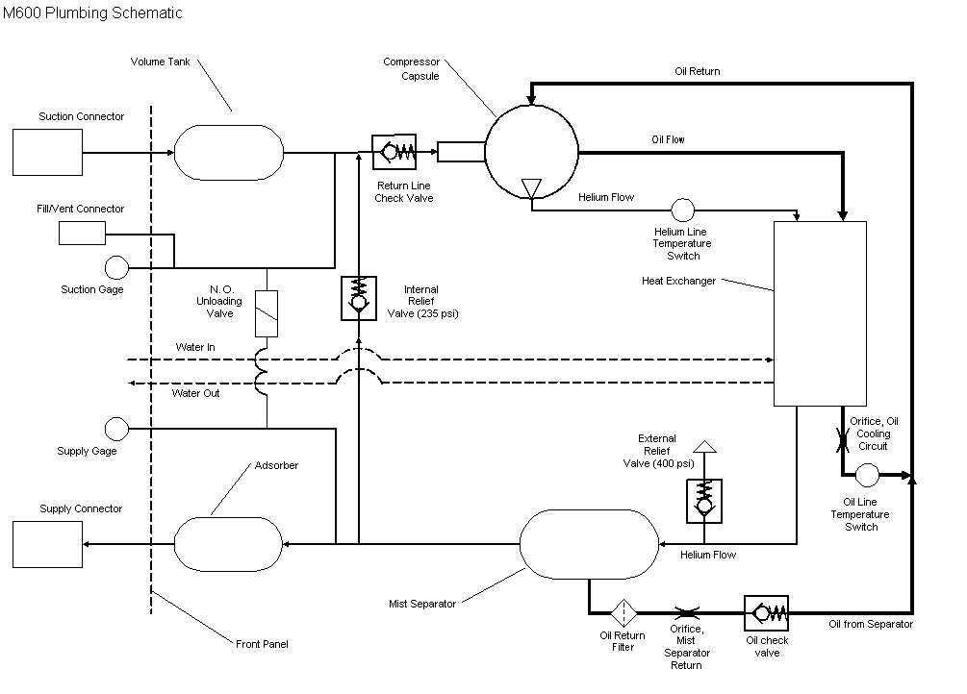
Flow diagram of the compressor system

3. TECHNICAL SPECIFICATION

3.1 SUMMARY SHEET

COMPRESSOR SPECIFICATION | UNITS | M600-HV | M600-LV
VOLTAGE REQUIREMENTS (±10%)
50HZ-3 PHASE | V | 400 | 200
60HZ-3 PHASE | V | 460 | 230
POWER REQUIREMENTS
50HZ-3 PHASE | KW | 8.2 | 7.5
60HZ-3 PHASE | KW | 8.8 | 7.8
OPERATING CURRENT WITH WARM COLD HEAD
50HZ | A | 10 | 21
60HZ | A | 10 | 21
REMOTE CONTOL VOLTAGE | VAC | 24 | 24
HELIUM CONNECTORS | IN | ½” Aeroquip | Same
STATIC HELIUM PRESSURE
50HZ | PSI (bar) | 240(16.5) | 240(16.5)
60HZ | PSI (bar) | 240(16.5) | 240(16.5)
RETURN HELIUM PRESSURE
50HZ | PSI (bar) | 50 | 50
60HZ | PSI (bar) | 50 | 50
SUPPLY HELIUM PRESSURE
50HZ | PSI (bar) | 280 | 280
60HZ | PSI (bar) | 300 | 300
COOLANT DATA
FLOW RATE (MIN) | GPM | 1.5 | 1.5
MIN. INLET TEMPERATURE | °F(C) | 40(5) | 40(5)
MAX. INLET TEMPERATURE | °F(C) | 85(30) | 85(30)
WEIGHT | Lb(kg) | 230(105) | 230(105)

  - OPERATING AND COOLANT CONDITIONS
    - OPERATING CONDITIONS:
When the compressor is operating, the ambient temperature must remain between 40°F and 104°F (5°C and 40°C).

    - COOLANT CONNECTIONS:
The standard connections on this compressor, for the coolant system, are 3/8” Swagelok connectors. Connections can be modified to meet customer requirements.

3.2.3 COOLANT QUALITY
Heat exchanger manufacturer recommends 1200-840 micron strainer on water supply and the following water requirements:
Electrical conductivity: >50 μS/cm
Iron: <1.5 mg/l
Manganese: <0.5 mg/l
Ammonia: <2 mg/l
pH value: 6 – 9
Chloride: <100 mg/l
Free carbon acid: <20 mg/l
Nitrate: <100 mg/l
Sulphate: <50 mg/l
Sulphide: 0 mg/l

  - ELECTRICAL CONNECTIONS


    - POWER INPUT
The power input can be adjusted to accommodate the different volt outputs from the customer.

3.3.2 MAIN CABLE AND LEADS
Production units can be fit with a variety of cord lengths and connectors. Which polarized connector, if any, are to be fitted to production units is yet to be determined.

3.3.3 COLD HEAD OUTPUT
The stock compressor will have the ability to control Austin Scientifics’ cold heads. Compressors can be easily fitted with a wide variety of cold head drives, connectors and cables to meet customer requirements.

3.3.4 Auto Restart Function
Our unit will have an automatic restart with brownout or blackout in power, when power is reapplied to the system. A manual reset will be necessary for a unit that stops operating with a fault condition.
4. INSTALLATION

4.1 UNPACKING AND INSPECTING
Once the units have been received, examine the packaging for signs of damage. This type of packing is reusable for these compressors.

Unpack the equipment and verify that no damage has occurred in transit. Check the tip and tell devices and the pressure gauges for signs of mishap during transit. The tip and tell device should insure that the unit has not been transported at an angle greater than 45° and the pressure gauges should read 240psi±10%.

The unit comes with a removable castor frame. We have the option to install feet, castors or rails, depending on the customer requirement.

If damage is detected contact the carrier and Austin Scientific as soon as possible.

  - MOUNTING
    - MAX OPERATING ANGLE
The compressor unit can be installed and operate with a maximum tilt of 10° in any direction.

    - FLEXLINES and CONNECTORS
The lines and connectors have been equipped with self-sealing coupling, this maintains the positive seal so no helium can escape during any maintenance.

These couplings should never see oil or grease and before any installation check all connections for foreign material and clean if necessary. Verify that all flat seals on the male connectors are in good condition and replace if necessary.
Work with the flex lines only if the compressor switch is in the off position and the internal pressure is below 400psi.

Never twist the flex lines.

Tighten down coupling as far as possible and then back it off by ¼ of a turn.

    - CONNECTING THE COLD HEAD
Connect the flexline from the compressor supply; this is marked with a green washer, to the inlet of the cold head. Then connect the flexline from the compressor return; this is marked with a red washer, to the outlet of the compressor. This can be changed with customer requirement.

Crossing the connection on the cold head will cause damage to the internals of the cold head.

With the appropriate cable supplied from Austin Scientific, complete the connections form the compressor electronic box to the electrical connection on the cold head. This will supply power and logic to the cold head.
5. OPERATION

  - SWITCHING ON
Turning the compressor on will automatically start the compressor and cold head. It is not recommended to run a compressor without all the proper connections verified.

  - NORMAL OPERATION
The helium used for this compressor must be ultra high pure quality (99.9999% pure) any impurities can cause problems inside the cold head that the compressor is controlling.

  - SAFETY DEVICES
The unit is fitted multiple safety devices:
An external pressure relief valve
A thermal switch on the oil temperature
A thermal switch on the helium temperature
Fuses for the main power
Fuses for the cold head
An internal pressure relief valve
Electronic Phase monitoring device
Motor overload and thermal switch for the compressor

- MAINTANENCE AND SERVICE
Before any service verify that the power has been removed from the system

  - ABSORBER REMOVAL
The service interval of the absorber of the M600 is 20,000 hours (27.4 months).

The M600 absorber has been placed at the front of the unit, behind a removable cover, to facilitate replacement. Absorber replacement should take about 15 minutes. This is ideal for rack and rail mounted compressor units.

  - HELIUM PRESSURE ADJUSTMENTS
The helium charge can be increased or decreased by using the ¼” self-sealing connector on the front of the unit, this connection is marked by a white washer.

Never charge the compressor above a static pressure of 250psi (17.2bar)

7. TROUBLE SHOOTING
For any trouble or questions installing and operating the M600 unit please contact the service department of Austin Scientific at:

Austin Scientific
Phone (512) 441-6893 x 112
Fax (512) 443-6665

RETURNING EQUIPMENT

Before returning any equipment, please contact Austin Scientific to receive special instructions and to obtain a Return Good Authorization (RGA) number.

Austin Scientific
4114 Todd Lane
P.O. BOX 18863
Austin, TX 78760
(512) 441-6893
FAX (512) 443-6665

Austin Scientific
West Coast Service Center:
500 Laurelwood Road #9
Santa Clara, CA 95054
(408) 496-0782
FAX (408) 469-0785

